Tuesday, 22 September 2026, postcard

Cannes and our last chance at real French food

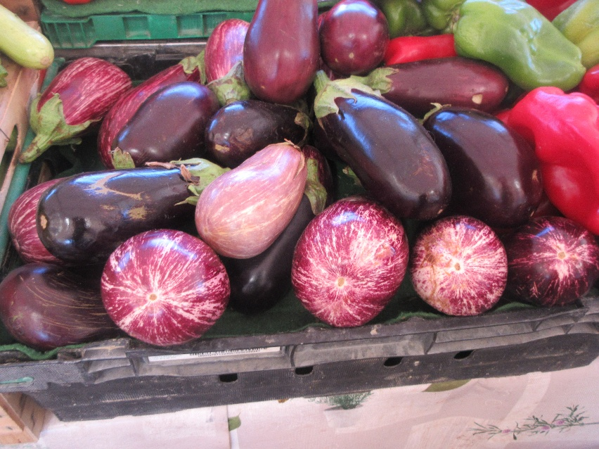
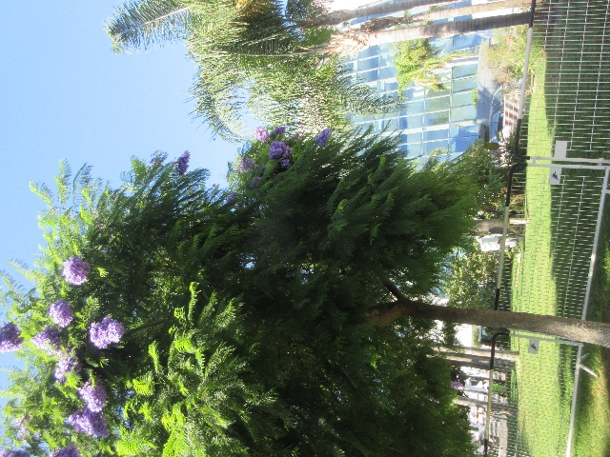
Rachel and I were the only "gentle walkers," so we had a guide to ourselves for the morning. We got to see the famous headquarters of the Cannes Film Festival, including the staircase where the red carpet is laid out. It was cordoned off while we were there, but tourists were taking selfies at a similar staircase on a different side of the building. Purple jacarandas were in bloom.

We visited the covered market (for me) and the major shopping street (for Rachel).

At the end, we had kind of a forced march to get back to the hotel to meet David at noon, as promised, but we were only a little late and still had time to walk to Bistro les Canailles for our 12:30 pm reservation.

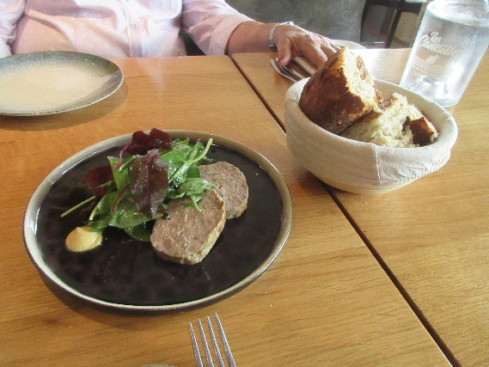
What a great restaurant! We split the house terrine three ways.

I loved my sautéed foie gras with berry compote and crispy hash browns.

Rachel and I both loved our salads of confit gizzards, sautéed chicken livers, and boiled egg, all on top of salad greens.

David loved his onglet (hangar steak) of veal with shallot sauce and fries, and we were all delighted with our desserts.

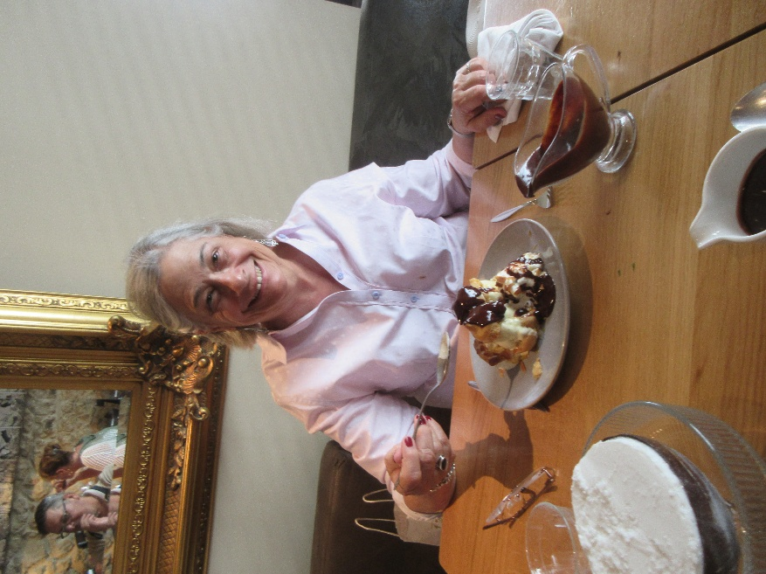
I was a little disappointed that they were out of clementine sorbet in the shell, but the coconut sorbet in the shell (with chocolate sauce!) was great, as were the profiteroles that Rachel and David both ordered.

I'd go back to that place any day!

The evening meal was the cruise farewell dinner, in the second subbasement of the hotel (the place has, count 'em, five floors below street level).

I hadn't realized how green the lighting in that room was until I looked at my photos later!

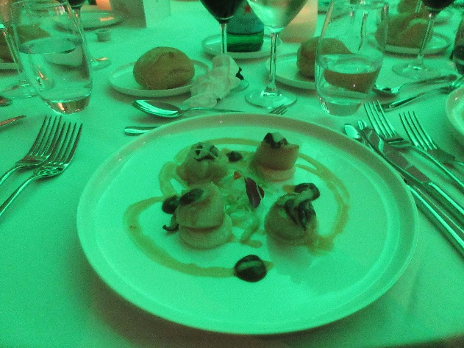
The first course was scallops and was pretty good.
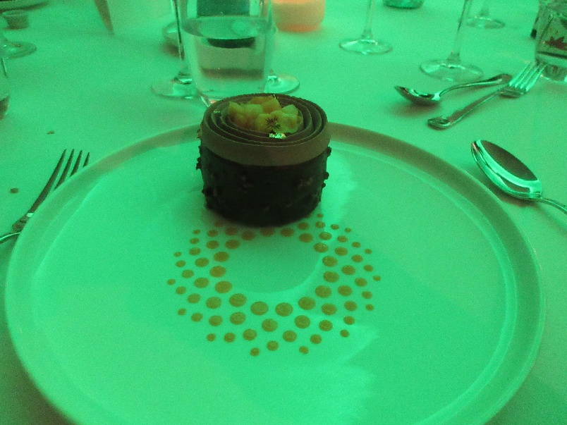
And the dessert was both delicious (once I spent some time removing all the bits of gold leaf) and spectacular looking (the spiraling dots are not part of the plate; they're dabs of passionfruit purée).

But the main course—poached cod—was disastrously oversalted. Something had clearly gone wrong in the kitchen. Everyone commented on it, and I could only eat about two-thirds of it before I started to get sore spots on my tongue. The very tangy passionfruit in the dessert made the sort spots worse, so I could only eat about a fourth of it.

The next time we're in Cannes, I might stay at the Marriott, but apart from breakfast, which was okay, I wouldn't eat there on a bet.

